**Organizational Design Plan**

for Master of Science in Organizational Leadership

Strategic Innovation and Change

Vinay Merchant

University of Denver

August 20th, 2023

Faculty: Brian Cicero, PhD

Director: Molly Smith, PhD

Dean: Michael J. McGuire, MLS

**Introduction & Overview of Xcel Energy**

For Xcel Energy’s success in the clean energy transition, the multi-state utility must focus on managing change and innovations within its organization through a culture of collaboration, a structured implementation plan, and a commitment to innovate. To be successful in the Clean Energy Transition, Xcel Energy needs to embrace the changes faced, like new revenue sources and operations, as well as invest in re-strategizing and change management efforts. To successfully navigate the clean energy transition and prepare for future unforeseen challenges, the utility should focus on creating a collaborative culture and structure, sculpting a unique strategic implementation plan, and supporting innovations through development and implementation methods.

**Internal & External Assessment**

External factors also support or further challenge Xcel Energy. Working as a highly regulated monopoly in service areas, Xcel Energy files program offerings with the governing Public Utilities Commission and must receive approval before rolling out any new offerings; these filings occur every three to five years. In addition to these filings, regulation obligates the organization to provide equal service opportunities to all service area customers. Other external factors include increased gas and electricity usage from customers, increased costs of natural gases and materials, technological advancements within the energy sector, and political change. While facing specific changes and challenges, Xcel Energy’s competitive advantages have been its access to resources and capital, internal investment into the education and training of employees, an extensive labor and corporate workforce, and its longstanding history and infrastructural assets already in place. Matching the nature of large corporations, Xcel Energy utilizes a complex organizational structure with inefficiencies in inter-departmental communication and collaboration. With the organization expanding into new revenue sources supporting clean energy, teams in these areas face significant challenges from the lack of oversight for the end-to-end process. Considering these cultural and business model weaknesses, leadership within the large utility has promoted a new initiative, called the One Xcel Energy Way, which receives support from consultant Lean Business Solutions on progressing the organization forward during growing pains and changes through strategic initiatives and training offerings.

**Organizational Structure**

Xcel Energy’s Organizational structure follows its complex business model. The large utility consists of four sub-organizations each of which focuses on a different state’s service area. The corporation focuses on generating and powering the grid, transmitting, and distributing energy, maintaining infrastructural assets, and introducing sustainable energy sources into the energy supply. In compliance with regulation, Xcel Energy files program offerings through the Public Utilities Commission every three to five years. Currently, the organization structure matches the complex operations of the utility. With operating needing significant inter-departmental collaboration and communication, the matrix structure matches the organization’s needs. The matrix organizational structure allows for several teams to work on operational overlaps between departments. One point of contention for this structure comes from the need to report to several leaders and teams (Communication Coach Alex 2018.) Employees working in this structure need a clear vision of the teams they need to work with, and how their roles and responsibilities impact overall operations.

**Changes to Current Design**

Aligned to the changes the organization is facing, Xcel Energy’s main challenge is the clean energy transition. The clean energy transition introduces new opportunities and challenges like offering electric vehicle public chargers as a new revenue source or expanding the capacity of the power grid to accommodate society’s increase in energy consumption. The current organizational design prevents the efficient implementation of new technologies and innovations. The Design Thinking Process (**Figure 1**) follows a five-step process to identify and understand challenges, generate solutions, experiment, evaluate, and develop solutions in response to the societal and industry-wide changes utilities face (Shields 2021.). This process would be effective for Xcel Energy because of the organization’s outlook on experimentation and failure. The common saying goes: “Experience is the best teacher.” Design Thinking suggests intentionally incorporating opportunities to experiment and test ideas in the hope to learn from them. Google practices a similar activity through its “Launch and Iterate” method. The “Launch and Iterate” Method suggests that Google Launch beta version of offerings for users to test and suggest critiques and feedback for the organization to improve their product or service, which the organization takes in and iterates (Ferman 2019.)

**Implementation Tools**

Xcel Energy’s success in the clean energy transition depends on the organization’s ability to innovate and implement changes in alignment with society’s energy production, distribution, and consumption needs changing. In connection with Design Thinking’s five-step process, ISO 56002’s Innovation Model provides insight into how an organization can implement, track, and improve innovative thinking and change management. **(Figure 2)** This Innovation Model follows a several areas of innovation from understanding the value in innovation and intent to innovate to implementing changes within operations and subsequently looking for improvement opportunities. The model also uses a concept called stage-gating to aid decision-makers in evaluating whether an idea or solution is worth development and implementation as it’s important for any organization to prioritize the changes made (Ferman 2019.) Time and capital restraints stand as two major criteria for Xcel Energy when determining next steps on innovation implementation. Another key activity in implementing changes within an organization is tracking and communicating progress. A few tools for determining KPIs for measurement of innovation are the four components of measuring innovation performance. **(Figure 3)** By evaluating innovation performance by Image, Outputs, Culture, and Impact, Xcel Energy fulfills their obligation to all service area customers, tracks the organizations production, progress, and impact in the clean energy transition, as well as opens for internal feedback loops from employees. The goal of the four components is to capture what the world believes, what the company produces, what employees believe, and how the markets react. Lastly, implementation requires detailed, micro tracking of activities and communication to leaders. The Innovation insight store provides structure on how to best capture innovation activities and what to communicate to leaders to best support changes. **(Figure 4)** The insight store maintains value from the data collection of innovation activities within the organization. Starting with the organization’s data, leaders can analyze mathematical happenings across operations and create problem statements for innovators to solve. Innovation events, around these problem statements, can be helping to spark culture innovation and provide platforms for employees to perform. As a result of these events, ideas and solutions are chose to be developed. Using Innovation performance scorecards and dashboard, organizations can evaluate the progress innovations have undergone at a more aggregate view. Rewards and recognition also play important roles as both incentivize employees to continue innovating and engaging in events. Lastly, the ideas or solutions generated and developed, in reaction to the proposed problem statements, are communicated to leaders, along with performance indicators. Leadership’s role in innovation and implementation stands as to support the growth of innovation within the organization and envision potential for future growth within operations or the innovative process. Utilizing Design Thinking along with the ISO 56002 Model’s tools, Xcel Energy can not only generate ideas for innovation or address ongoing challenges, but also measure innovative progress and communicate it clearly to leadership.

**Conclusion**

The clean energy transition forces Xcel Energy to change their operations and business model, however, to succeed in this transition the utility needs to embrace innovation within their organization. With new guidance on creating a collaborative culture and structure, sculpting a unique strategic implementation plan, and supporting innovations through development and implementation methods, Xcel Energy now has tangible models, methods, and tools to face their greatest challenge so far in the long history of the organization, to become net-carbon free by 2050.

**Citations**

Communication Coach Alex. 2018. "Organizational Structure." 4:49, video. <https://www.youtube.com/watch?v=zUd0UNHyy60>

Ferman, Len. 2019. Business Creativity and Innovation: Perspectives and Best Practices. San Diego: Cognella Academic Publishing.

Shields, Kerri. 2021. “Design Thinking.” In Leading Innovation, Chapter 7. eCampus Ontario. [https://ecampusontario.pressbooks.pub/leadinginnovation/chapter/chapter-7-design-thinking/.](https://ecampusontario.pressbooks.pub/leadinginnovation/chapter/chapter-7-design-thinking/)

**Figures and Graphics**

**Figure 1: “Design Thinking” (Shields 2021)**

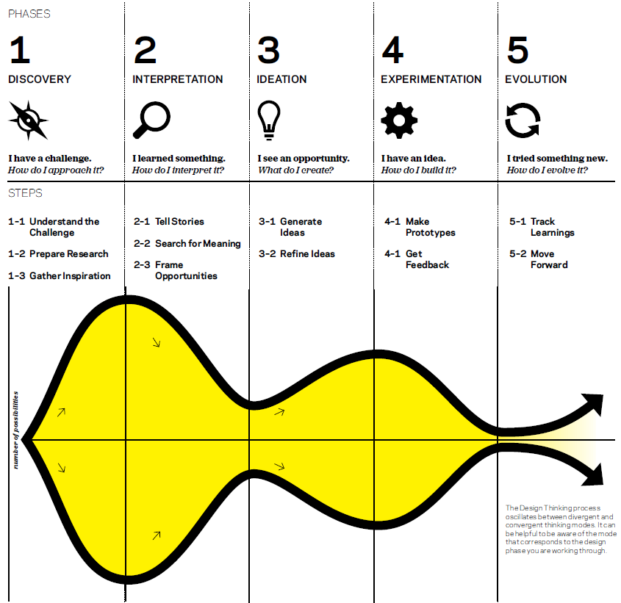

**Figure 2: “ISO 56002 Model” (Ferman 2019)**

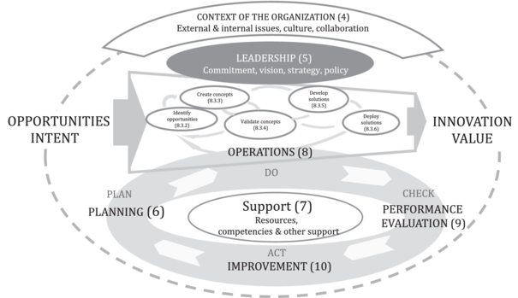

**Figure 3: “Innovation Performance Focus Areas” (Ferman 2019)**

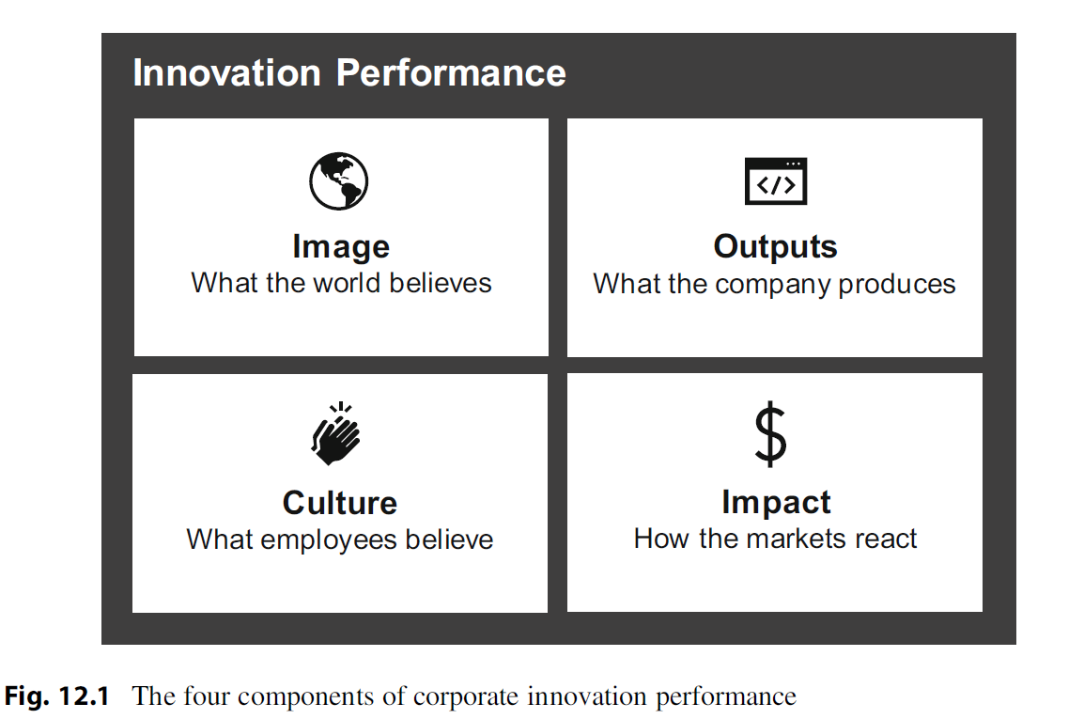

**Figure 4: “Innovation Insight Store” (Ferman 2019)**

